MOBILE DEVELOPMENT PROJECT BY CRAIG – PT.2022.Z4Z2L2

Table of Contents

Description of Assignment 2

How to Use 2

Values to Enter 2

Handling Errors 2

Screenshots 2

App CS 3

AccountPage XAML 3

AccountPage CS 4

Database Connection CS 4

6](#_Toc157990107)

Login Page Xaml 7

Login Page CS 7

MainPage XAML 8

MainPage CS 9

Model CS 10

RegistrationPage XAML 11

RegistrationPage CS 11

TransferPage XAML 13

TransferPage CS 13

# Description of Assignment

The assignment is a Bank called Sisonke Bank. The objective of this assignment is to build a Xamarin App that uses SQLite that a user can use to create an account. Login. View their details. Transfer Money over to Accounts and logout when they deem fit.

# How to Use

To open the application. Open the project file in the folder using Visual Studios. Visual Studios must have Mobile Development plugins installed to resume. Once opened the program will be able to run on any android Device. Unfortunately, the system cannot be tested using IOS due to lack of such device, however, it should yield the same results.

# Values to Enter

When asked to login. Please present the information used during the Registration Page.

Note. The register button is a textlink below if you have trouble finding it.

# Handling Errors

When experiencing an error. On Visual Studios stop the application or use task manager to kill the program. Please then report the error on the marksheet or comment on MYLMS

# Screenshots

Screenshots of what is manually coded will be added. Assembly info or other information will not be added.

## App CS

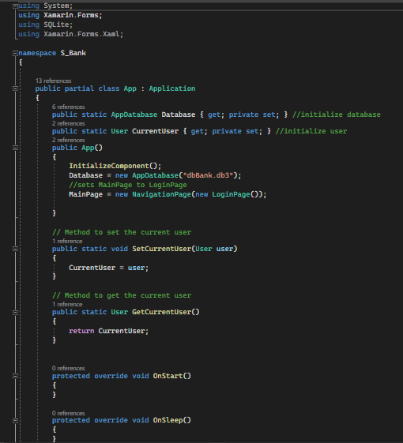

## AccountPage XAML

## AccountPage CS

## Database Connection CS

## Login Page Xaml

## Login Page CS

## MainPage XAML

## MainPage CS

## Model CS

## RegistrationPage XAML

## RegistrationPage CS

## TransferPage XAML

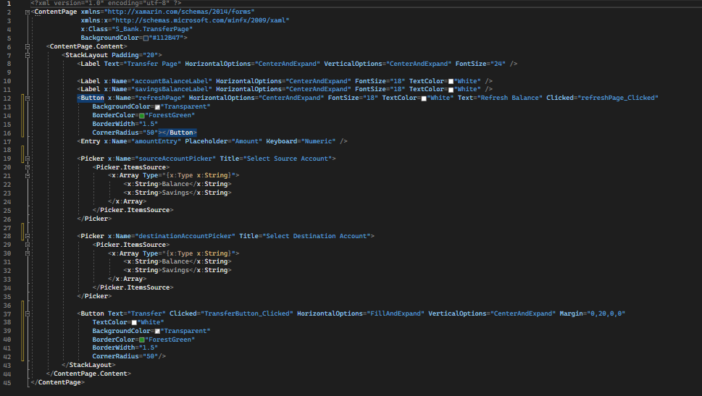

## TransferPage CS



